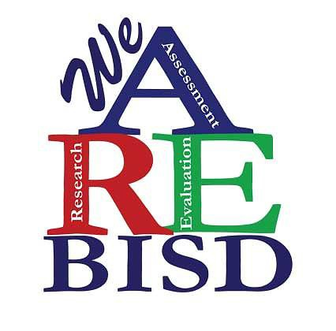

Brownsville Independent School District
Teacher / Staff Consent Form J

Note: This is a template. The information in italics will be completed prior to sharing with Teachers / Staff. Please do not include the italicized wording in your completed form, instead replace those words with the information specified.

NAME OF PROJECT: TEACHER / STAFF NAME:
CAMPUS:

Describe the purpose / context of the study.

- Please indicate what you will ask the teacher/staff member to do, and how much time you predict will be involved in participation, and the length of the study (how many times will data be collected).
- Please state how the identity of participants will be protected and who will have access to the project data.
- Please describe what form or forms the data you collect will be reported or otherwise shared.

- Please state here any risks or inconveniences that participants might incur. If there are none, include a statement so indicating. If there are risks, indicate what the risks are and what precautions you will take to protect participants. Describe the benefits of participating in the study and the compensation, if any, to participants.
- My consent is optional and voluntary. My decision whether or not to participate will not prejudice my present or future relations with (your institution's name here) or Brownsville Independent School District. If I decide to participate, I am free to discontinue participation at any time without prejudice. To the extent that my identity may be identified, if I withdraw from the project, my information will be removed from the project results.
- I understand that I am obligated to comply with all confidentiality requirements, including but not limited to the Family Educational Rights and Privacy Act (FERPA). In the event that student data is required for me to participate in this project, I will verify that the appropriate parental consent forms have been obtained for all students whose information will be used.

- I understand that, while this project has been reviewed by the Brownsville Independent School District, Brownsville ISD is not conducting the project activities.

Please check the appropriate box below.

I DO NOT agree to participate in this research project.

I agree to participate in this study.

If you later decide to withdraw your consent for participation in the study, you should contact the Project Director/ Researcher. You may discontinue participation at any time. The Teacher / Staff Member should keep a copy
of this form for his/her records.

Your signature below indicates that you have read and understand the information provided above and have had an opportunity to ask questions.

Signature
Date:

Teacher / Staff Member

Signature Date:

Project Director / Researcher

Print Form

