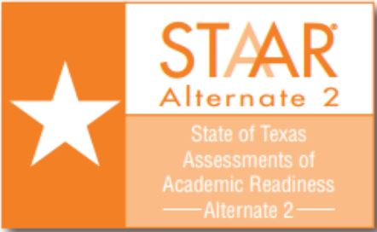
CAMPUS name 2022 Test Schedule

Test Administrator: Test Administrator #1

Week of (Date): March 28-April 1 Room #: d214
Time | MONDAY  3/28 | TUESDAY  3/29 | WEDNESDAY  3/30 | THURSDAY  3/31 | FRIDAY  4/1
8:30 | Subject  student name | Subject  student name | Subject  student name | Subject  student name | Subject  student name
12:30 | Subject  student name | Subject  student name | Subject  student name | Subject  student name | Subject  student name

Week of (Date): April 4-8 Room # d214
Time | MONDAY  4/4 | TUESDAY  4/5 | WEDNESDAY  4/6 | THURSDAY  4/7 | FRIDAY  4/8
8:30 | Subject  student name | Subject  student name | Subject  student name | Subject  student name | Subject  student name  Subject  student name
12:30 | Subject  student name | Subject  student name | Subject  student name | Subject  student name

Week of (Date): April 11-15 Room # d214
Time | MONDAY  4/11 | TUESDAY  4/12 | WEDNESDAY  4/13 | THURSDAY  4/14 | FRIDAY  4/15
8:30 | Subject  student name | Subject  student name | Subject  student name | Subject  student name | EASTER HOLIDAY
12:30 | Subject  student name | Subject  student name | Subject  student name | Subject  student name

Please Note: A student should be given only one test per day. Schedule student testing sessions at a minimum of 1hr and 45min.

Week of (Date): April 18-22 Room # d214
Time | MONDAY  4/18 | TUESDAY  4/19 | WEDNESDAY  4/20 | THURSDAY  4/21 | FRIDAY  4/22
8:30 | Subject  student name | Subject  student name | Subject  student name | Subject  student name | Subject  student name
12:30 | Subject  student name | Subject  student name | Subject  student name | Subject  student name | Subject  student name

Time | MONDAY  4/25 | TUESDAY  4/26 | WEDNESDAY  4/27 | THURSDAY  4/28 | FRIDAY  4/29
8:30 | MAKE UPS  VERIFICATION | MAKE UPS  VERIFICATION | MAKE UPS  VERIFICATION | MAKE UPS  VERIFICATION | MAKE UPS  VERIFICATION
12:30 | MAKE UPS  VERIFICATION | MAKE UPS  VERIFICATION | MAKE UPS  VERIFICATION | MAKE UPS  VERIFICATION | MAKE UPS  VERIFICATION
Week of (Date): April 25-29 Room # d214

