1. Log in to TESTHOUND
2. Select **MATERIALS** AND then
3. Select **SCAN TO BOXES**
4. Complete Fields as indicated in visual below:

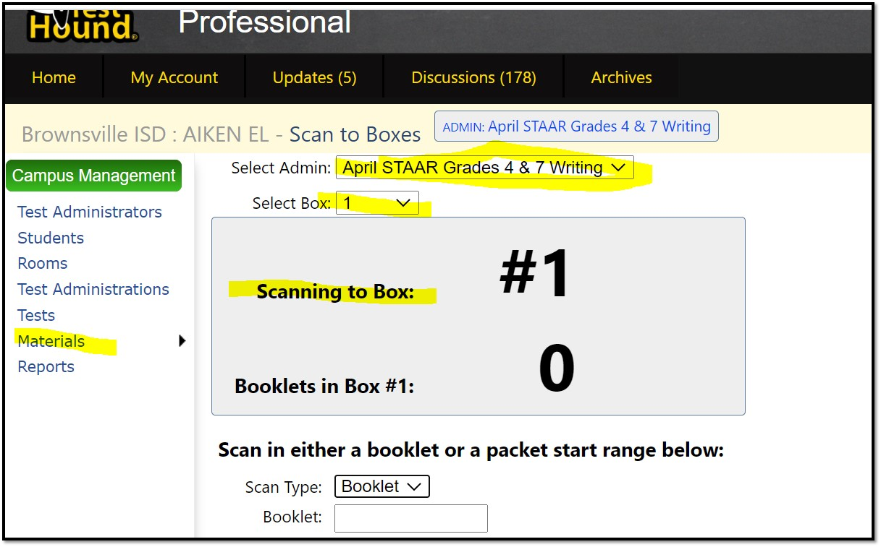

**KEY POINTS!!**

1. There are only 2 April Options: April STAAR EOC & April STAAR Grades 4 & 7 Writing.  Select the one applicable to your level.
2. You will be able to SCAN BOOKLETS and PACKETS.  Make sure to choose the appropriate option from the SCAN TYPE Drop Down!
   1. The BOOKLET Option is to scan BOOKLET by BOOKLET (think of the ones the students used ).
   2. The PACKET Option is to scan Packet by packet (think of the unused bundles of booklets still shrink wrapped 😊).  For this, you will scan the beginning and ending bar codes (top and bottom)
3. Under the **Select Box** Option, You will start to “fill in” Box one. Once the box is full, you will have to SELECT from drop down arrow BOX 2 to continue with scanning process.  Every time a box “fills up”, you will select a new box to place them in.  Follow Numerical sequence!
4. If you find yourself with an overflowing box…you just remove the booklets that DO NOT fit in let’s say box 1 and Go to the SELECT BOX option and change to Box 2. Now, scan the booklets you removed from Box 1 into Box 2.  The system will automatically “delete” the overflow from Box 1!

**Keep in mind that by clicking the** **tab on this SCAN to BoXES section, you will get access to an additional video and an article on how to scan STAAR Testing materials into boxes. See below:**

