Related Services - Preparing for an ARD meeting

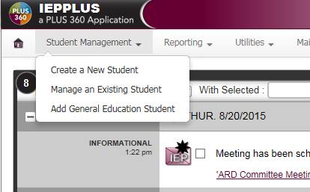

You can search by:

First Name

Last Name

Student ID

Or Birth Date

Select student

Click: Manage an Existing Student

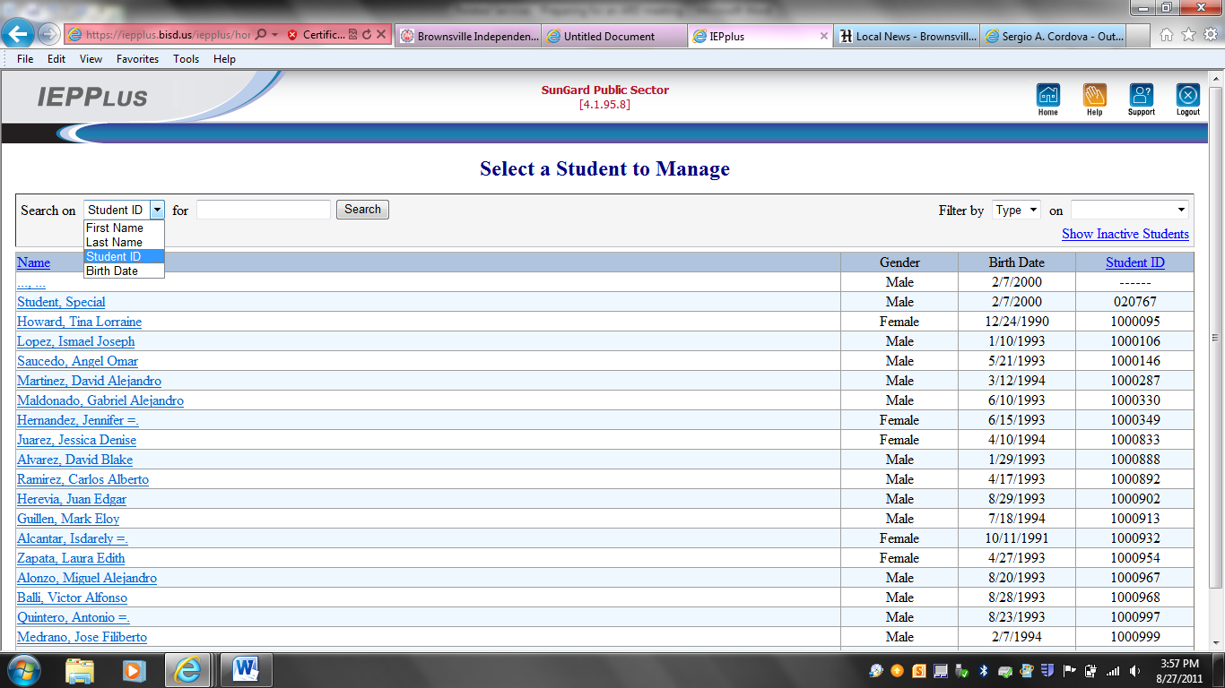

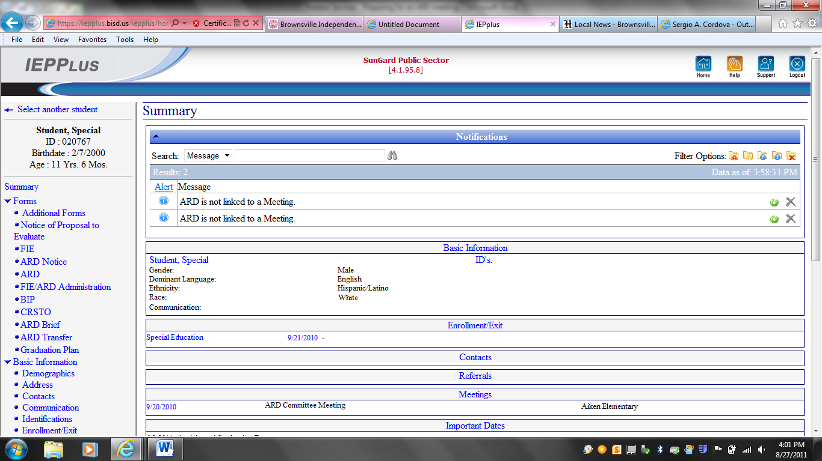

FIEs are on the left

ARDs are on the Right

The most current should be on top.

Click on ARD Name to open.

Click: FIE/ARD Administration

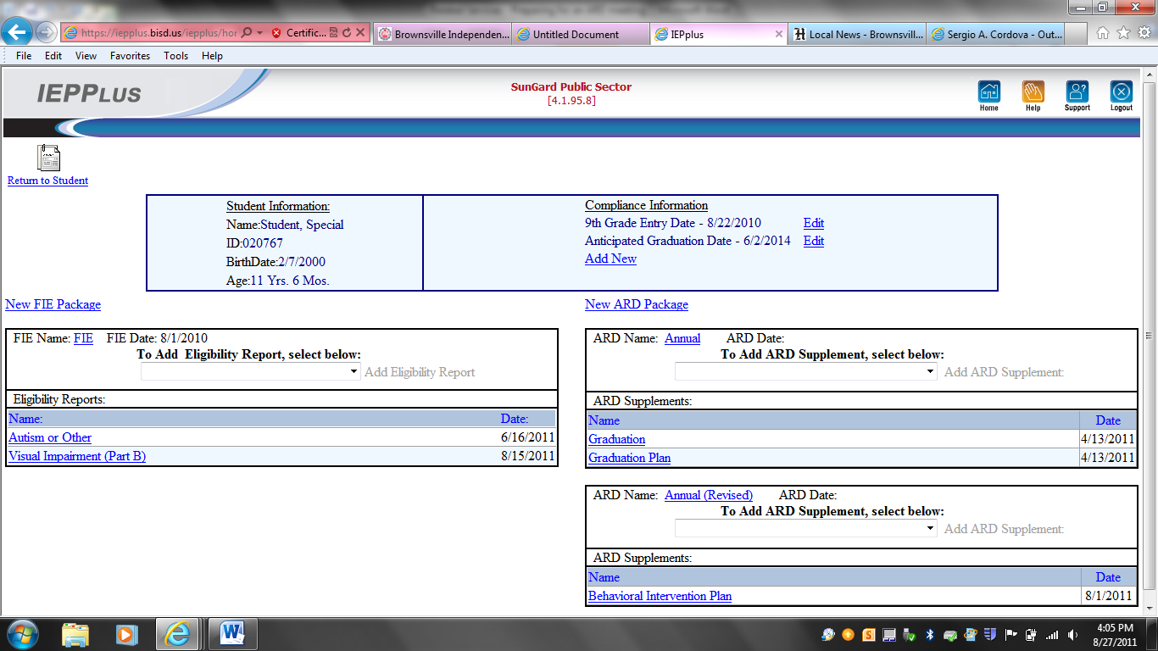

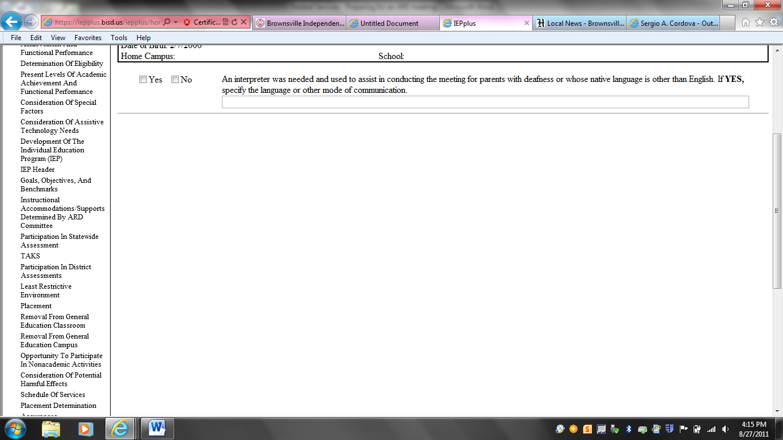

Use the Sections on the left to navigate through the ARD document.

The 3 sections you must complete are:

1. PLAAFP – Present Level of Academic Achievement and Functional Performance.

**(How is the student doing now?)**

1. IEP Header (add Counseling)
2. Goals and Objectives

**(What are we going to work on?)**

1. SOS – Schedule of Services

**(How often and how long I am going to meet with the student to reach the goal?)**

**PLAAFP**

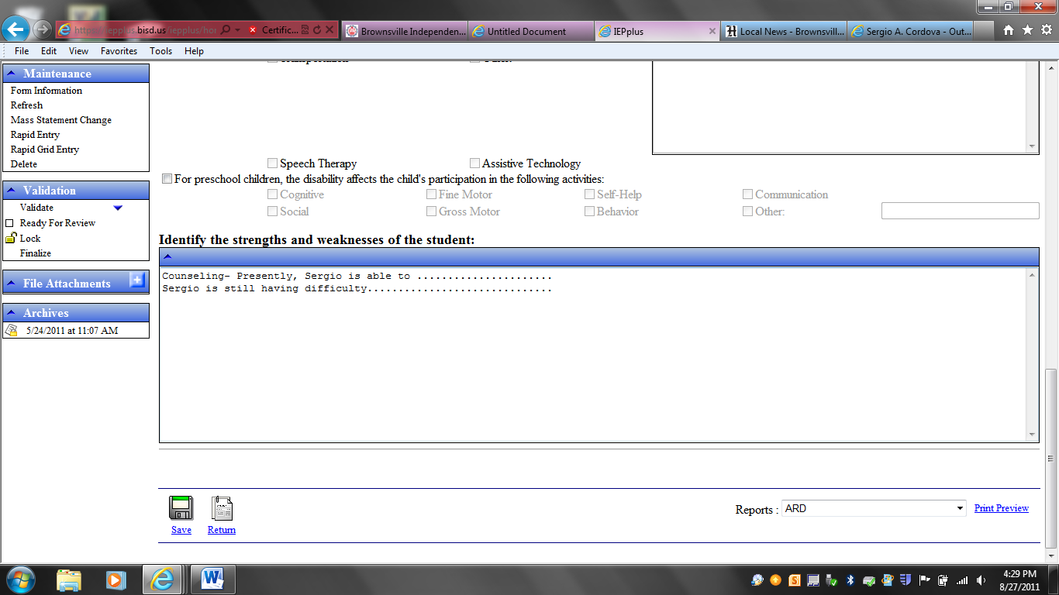

**Enter the Counseling PLAAFP in the box titled: Identify the strengths and weaknesses of the student:**

**Do not delete or change text already there. We all share the same box. The General Ed teacher, Special Ed teacher, and all related services personnel use the same box to enter the PLAAFP. Everyone addresses their own area of expertise.**

**IEP Header**

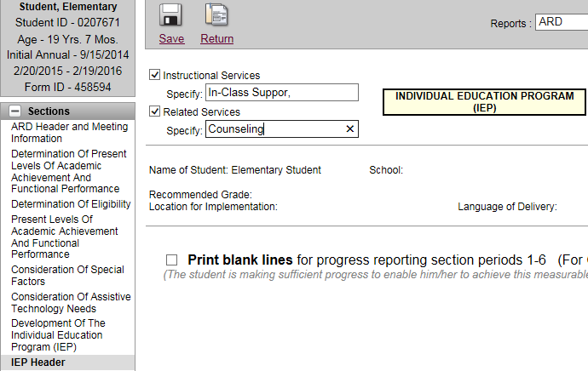

Click: Related Service

Specify: Counseling

**Goals and Objectives**

**Annual Goal**

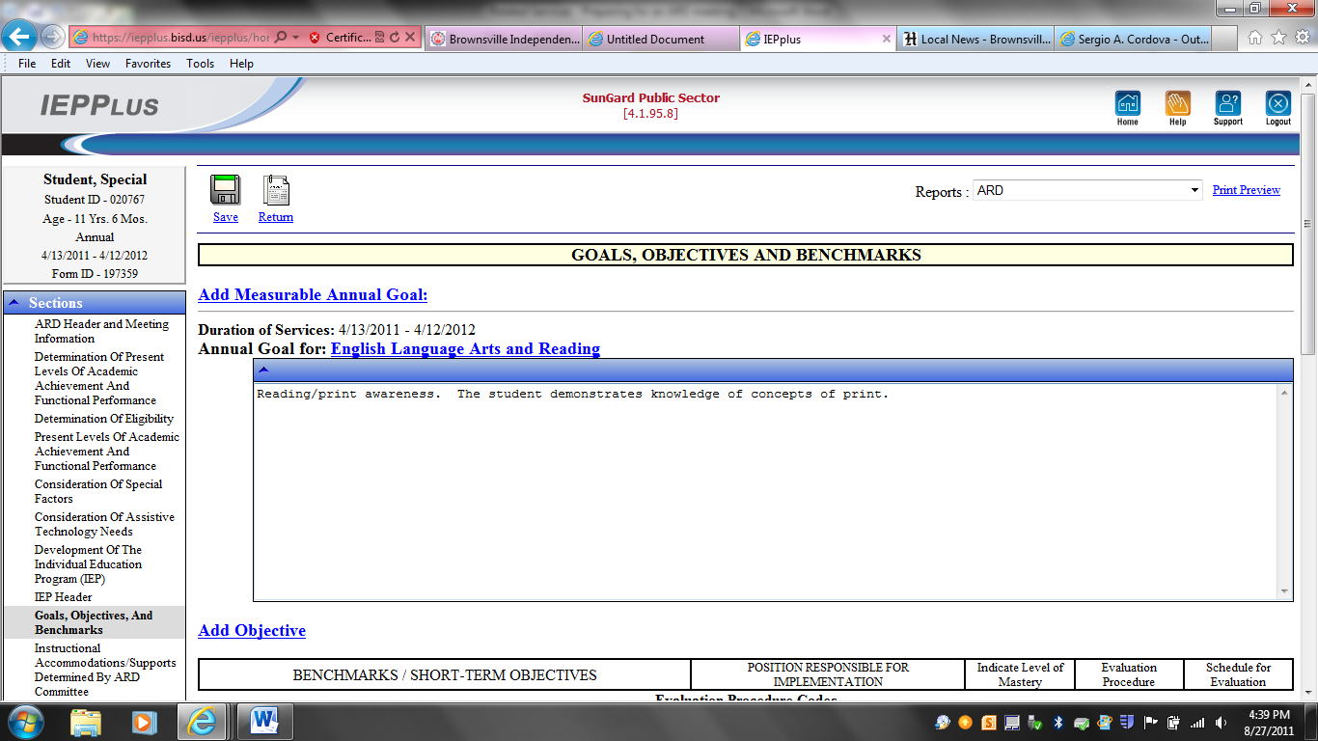

Click: Recommended

The correct dates should appear automatically

Click: Add Measurable Annual Goal

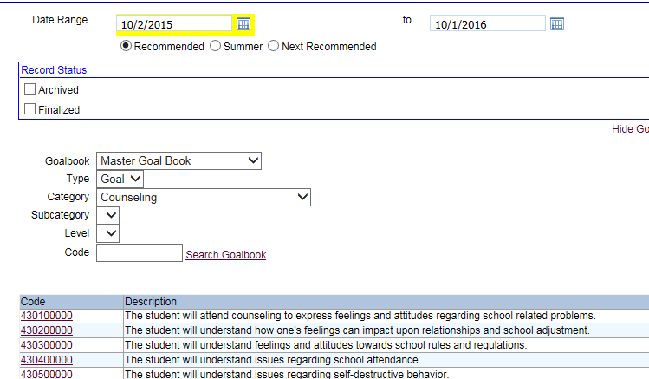

Category: Counseling

Pick a goal to work with.

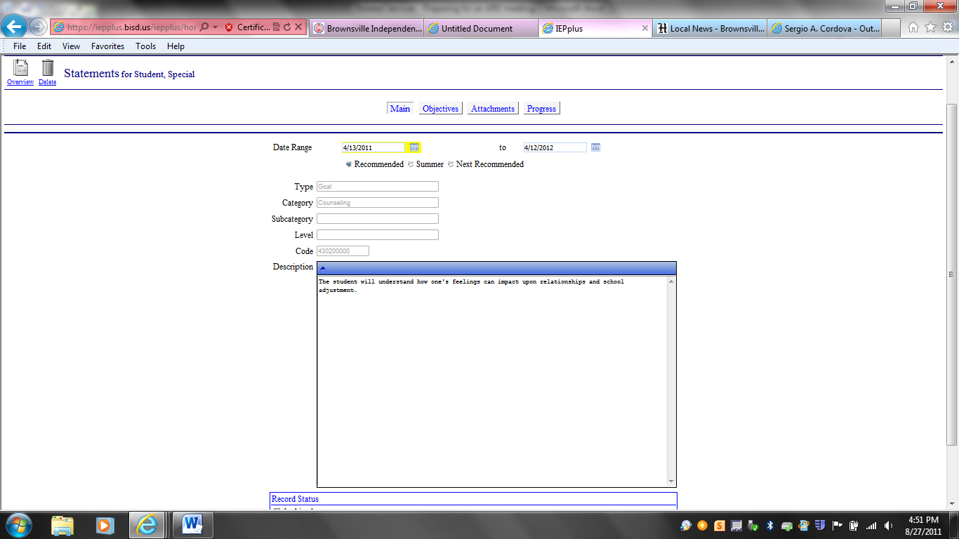

At this point you can edit the goal to individualize it to meet the needs of the student.

We need to add the 4 components required under IDEA.

Timeframe

Condition

Behavior

Criteria

|  |  |  |  |
| --- | --- | --- | --- |
| **Timeframe** | **Condition** | **Behavior** | **Criteria** |
| Within 36 instructional weeks | Using social stories and role play | Joseph, a 3rd grade student, given 3 choices, will orally state the appropriate behavioral choice | 4 out of 5 times. |

Add Objectives if appropriate

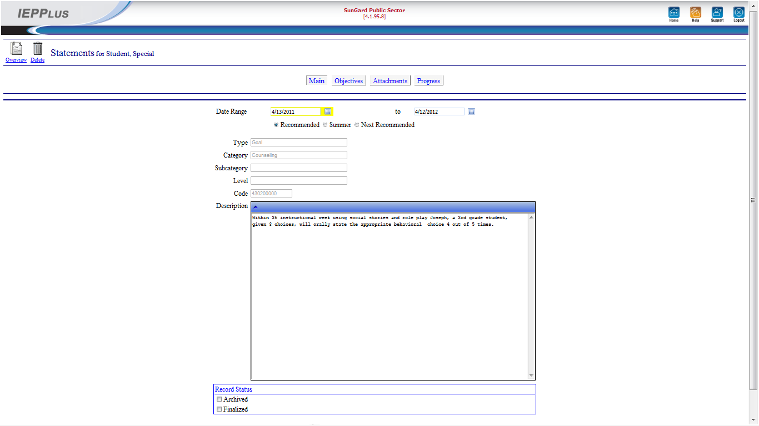

Click: Objectives

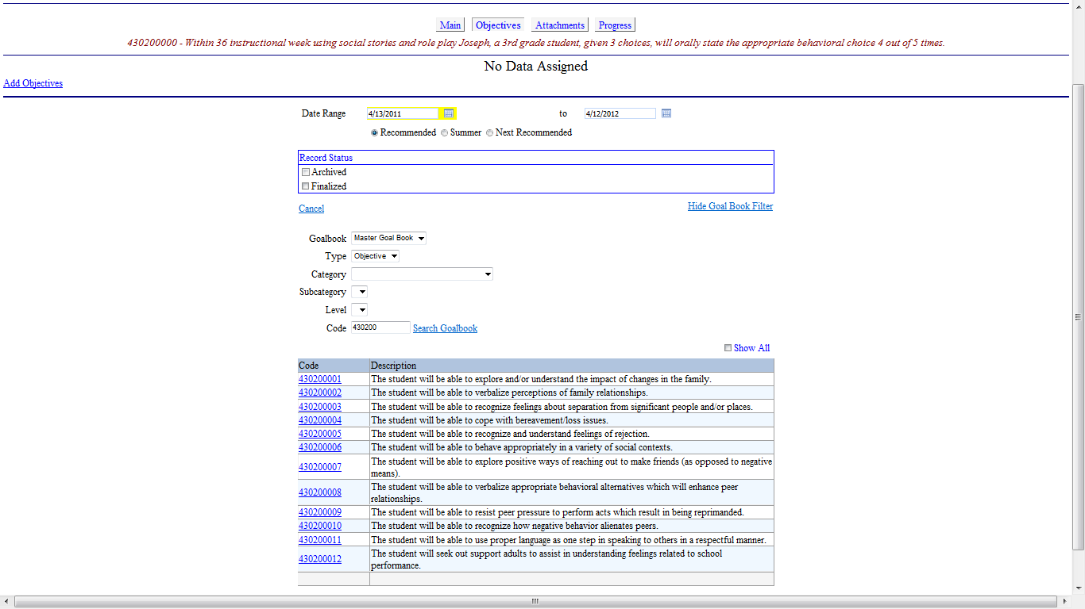

Click Category and select Counseling

Pick an Objective

Then click overview to save and return to the IEP page.

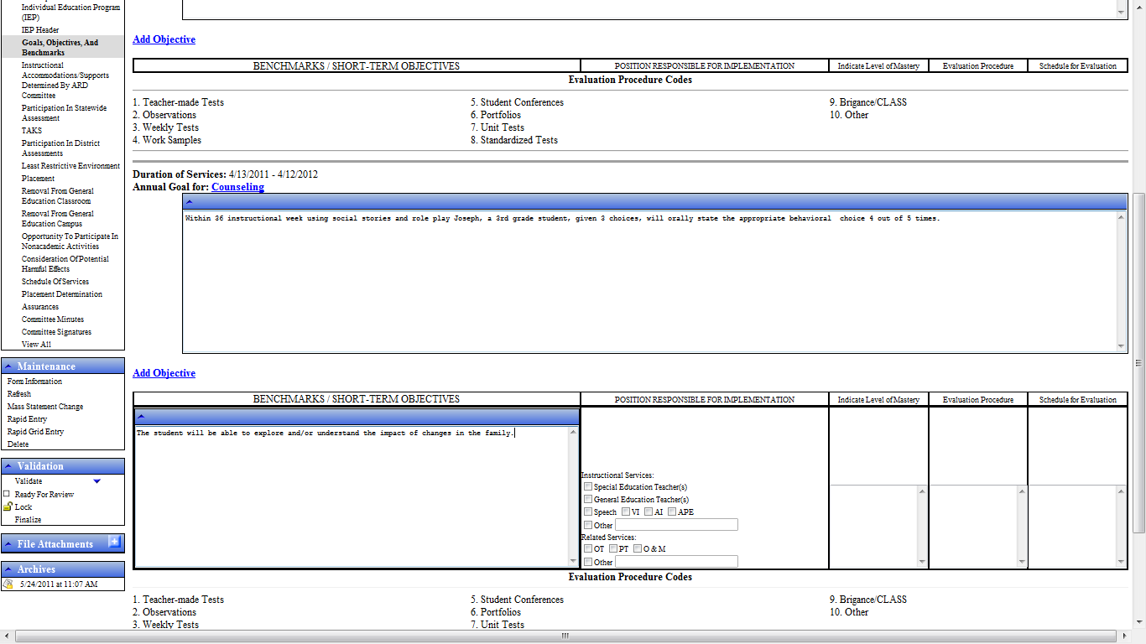

The Counseling Goal and Objectives that you wrote will appear here.

You need to edit the objective to add the 4 components (same as the goal).

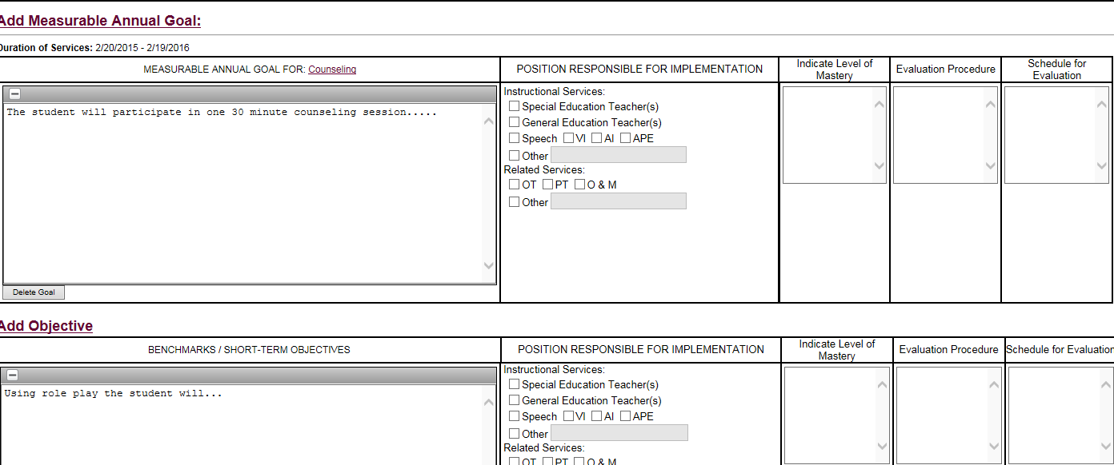

Example: Goal/Annual ARD Objective: 6 wks

Example: 80% (4 out of 5 opportunities)

Example: 2, 5, 10 (counseling participation)

For Objective enter same information as Goal

Click: Other and enter Counselor

**SOS – Schedule of Services**

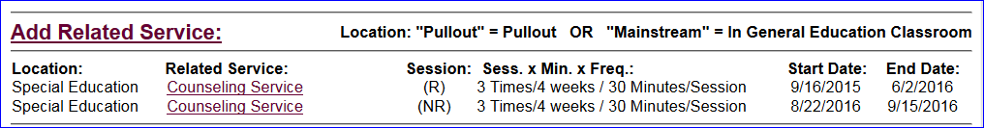

The software will automatically copy the related services that were provided last year. If you want to keep the same amount of sessions, then you do not have to change anything.

If you wish to change the amount of services provided, then click on the Counseling Service to adjust.

Make sure that you have services for ((R) Recommended (this school Year)) and ((NR) Next Recommended (next school year).

If the student has not received counseling before, then click: Add Related Services

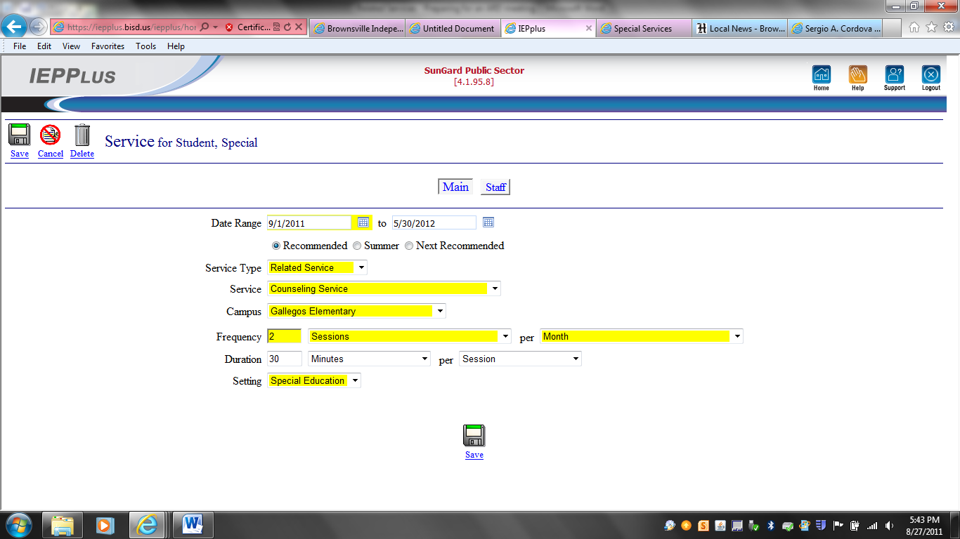

The Service dates appear automatically. Do not change the dates.

Fill in all yellow blanks.

Click: Save when you are finished.

Enter services for (NR) Next school year also.

You are now finished preparing for an ARD meeting.

Great Job!!!!!