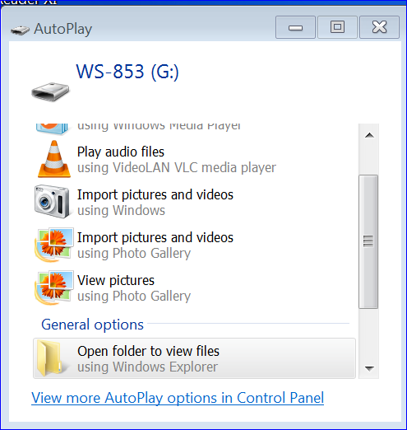
Steps for recording
Erase everything on the recorder before starting each new ARD meeting.
Record the ARD meeting.
When the ARD meeting has finished,
Insert the USB on the recorder to the Computer and wait for this screen to appear.

Click: OPEN FOLDER TO VIEW FILES

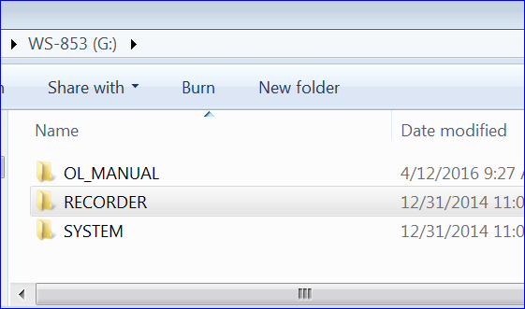

Click: RECORDER

Click: FOLDER A

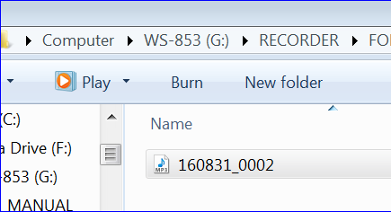

Click: BURN

Click on the file to listen and make sure you have the correct meeting.
Delete any other files that do not belong on the CD you are making.

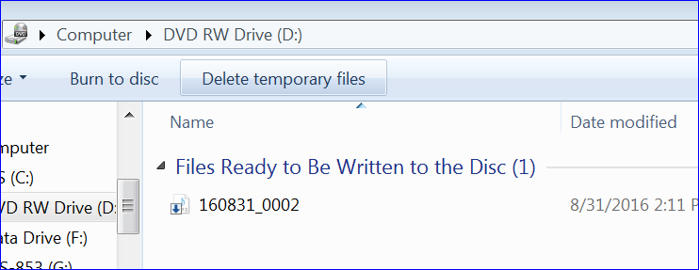
Click: BURN TO DISC

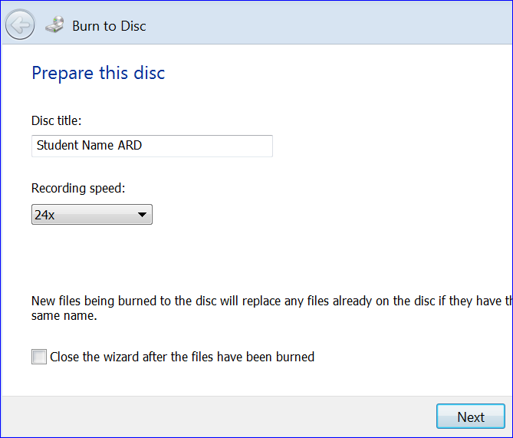

Insert a Disc
Add DISC Title and click NEXT

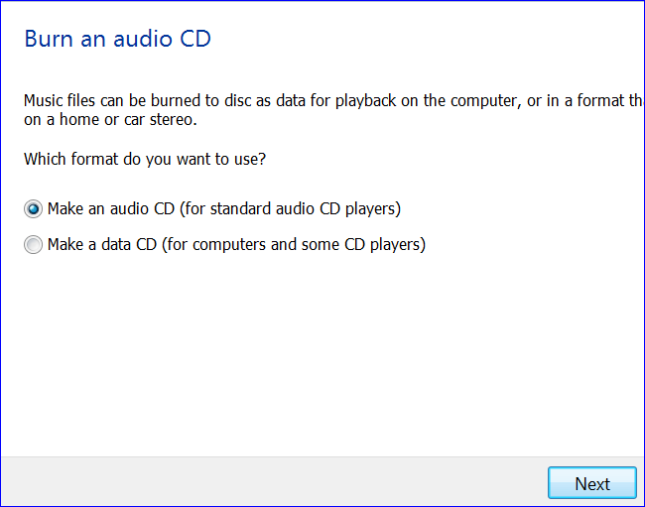

Click NEXT

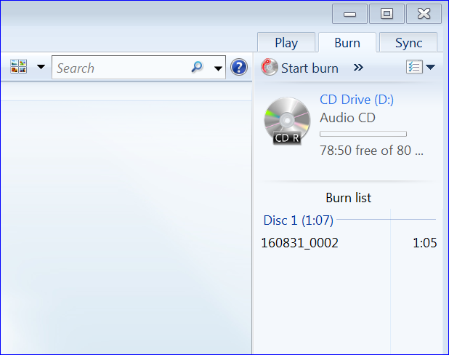

Click START BURN button
Play the CD to make sure you have the correct recording before you give it to the parents.

