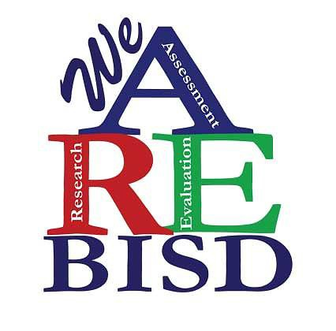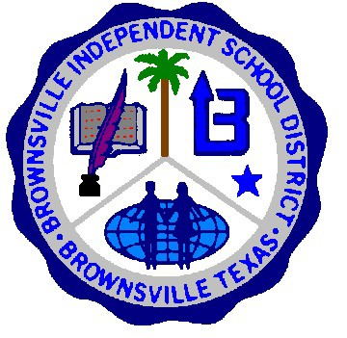

Brownsville Independent School District
Parent / Legal Guardian Consent Form H

Note: This is a template. The information in italics will be completed prior to sharing with Parents / Legal Guardians by the researcher. Please do not include the italicized wording in your completed form, instead replace those words with the information specified.

The researcher will provide this form in ENGLISH and SPANISH.

NAME OF THE PROJECT: STUDENT NAME:
CAMPUS:

- Please describe what you will ask the student to do, and how much time you predict will be involved in participation, and the length of the study (how many times will data be collected).
- Please describe all data you will collect from student records, such as test scores, attendance data, etc. and what you will do with this data.
- If you are requesting access to free/reduced price meal eligibility status, please state that you are requesting such access and include a statement indicating that the failure to allow access to this information will not affect eligibility for or participation in Child Nutrition Programs.
- The following statement will need to be included "The results of my student's participation in this project will be kept confidential unless I give prior written consent." Please state here how the identity of participation will be protected and who will have access to the project data.
- Please describe what form or forms the data you collect will be reported or otherwise shared.

- Please state any risks or inconveniences that participants might incur. If there are none, include a statement so indicating. If there are risks, indicate what the risks are and what precautions you will take to protect participants. Describe the benefits of participating in the study and the compensation, if any, to participants.
- My consent is optional and voluntary. My decision whether or not to allow my child to participate will not prejudice my present or future relations with (your institution's name here) or my child's school or teacher. To the extent that my child may be identified, if I withdraw my student from the project, my student's information will be removed from the project results.

- If my child participates in the project, I can get information about the project and copies of any surveys or tests given to my child by contacting (provide the name of the project contact and contact information here).
- I understand that, while this project has been reviewed by the Brownsville Independent School District, Brownsville ISD is not conducting the project activities.

Please check the appropriate box below.
I DO NOT grant permission for my child to participate in this research project.

I grant permission for my child to participate in this research project.

If you later decide to withdraw your consent for participation in the study, you should contact the Project Director/ Researcher. You may discontinue participation at any time. The Parent / Legal Guardian should keep a copy
of this form for his/her records.

I agree to the conditions listed above with the understanding that I may withdraw my child from the project
at any time, and that my child may choose not to answer any questions that he/she does not want to answer.

Your signature below indicates that you have read and understand the information provided above and have had an opportunity to ask questions.

Signature
Date:

Parent / Legal Guardian

Signature
Date:

Project Director / Researcher

Print Form

