2020-2021

BAC REMOVAL
ESCHOOL ENTRY/WITHDRAWAL
SCREEN

BAC REMOVAL ENTRY/WITHDRAWAL SCREEN PROCEDURES

- Students transferring within the district to a DAEP for disciplinary assignments will need to be withdrawn and entered on the eSchool Entry/Withdrawal screen. All Entry/Withdrawals will be handled by the sending campus.

- DO NOT begin this BAC withdrawal process until BAC personnel contacts the sending campus that student has reported for their first official school day at BAC.

- BAC personnel will notify sending campus of students’ first day reporting to BAC. At this time BAC will notify sending campus to drop their schedule. Sending campus will then begin with entering withdrawal on entry/withdrawal screen.

- The sending campus will withdraw the student with Code WAA and date student physically reports to BAC with comments notation of “BAC Removal“. The Withdrawal date is the “Date to begin at Home Campus” noted on the BAC Transition Form. Student schedule is dropped.

- The sending campus will open a new vector to enter the student at BAC with the same date student was withdrawn. The Calendar must be changed to 2.

- Upon completing assigned BAC days, the sending campus will withdraw the student with Code WAA the day after the students’ last day at BAC. Comments notation of “BAC Return“.

- The sending campus will open a new vector to re-enroll the student using the same date as the BAC withdrawal date. Change the calendar back to 0. On entry date schedule must be activated and attendance starts by sending campus immediately after BAC release date (there should be no gap in attendance dates).

- Sending campuses and BAC make sure Disciplinary action entry in eSchool corresponds with entry/withdrawal screen dates.

- Any special cases, please contact the PEIMS Department for assistance at ext. 8284

STEP 1 THROUGH STEP 2 – STUDENT LEAVING TO BAC

- ENTRY/WITHDRAWAL SCREEN PROCEDURES (Withdrawal to BAC)
DO NOT begin this BAC withdrawal process until BAC personnel contacts sending campus that student has reported for their first official school day at BAC.
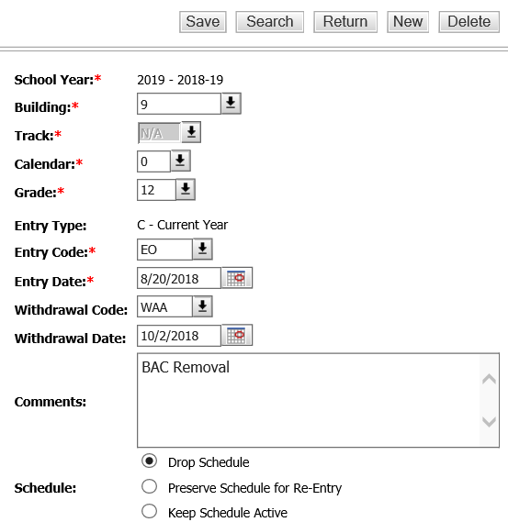

Use “Date to begin at Home Campus” noted on the BAC Transition Form.

Insert removal comment

Click on “Drop Schedule” and SAVE

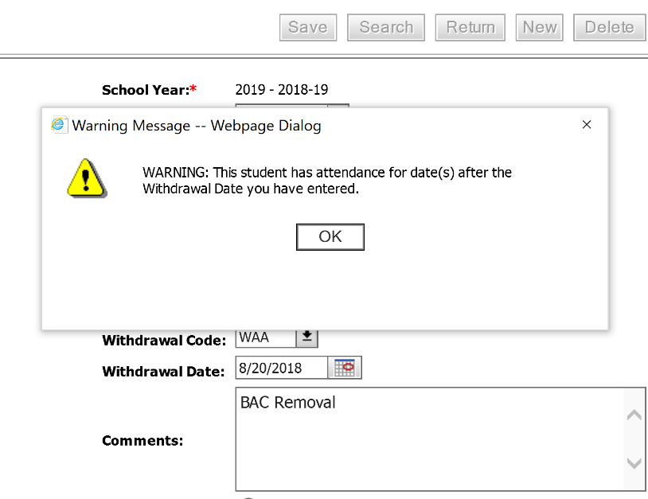

Click “OK” . (If this screen appears)

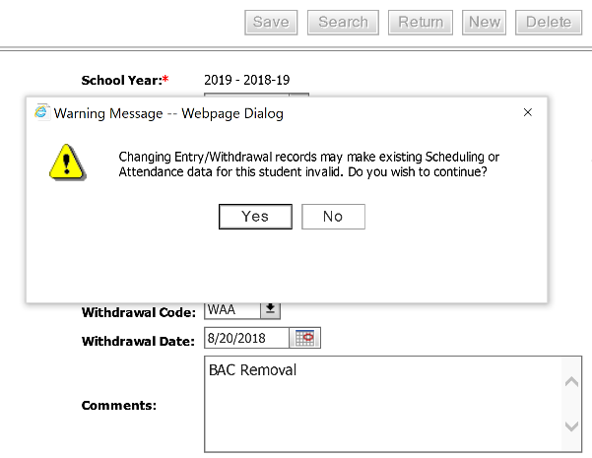
Click “YES” . Then SAVE.

- Enter a NEW vector with date student physically reports to BAC (Entry to BAC). Use same date for sending campus withdrawal date and new vector entry date.
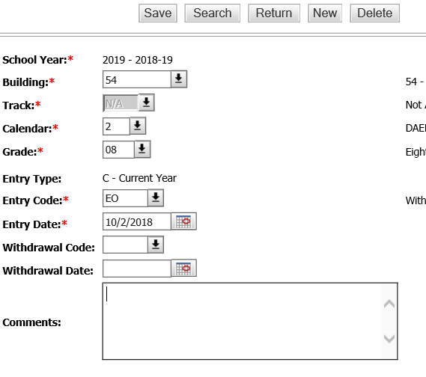
Calendar 2

Same date as withdrawal date

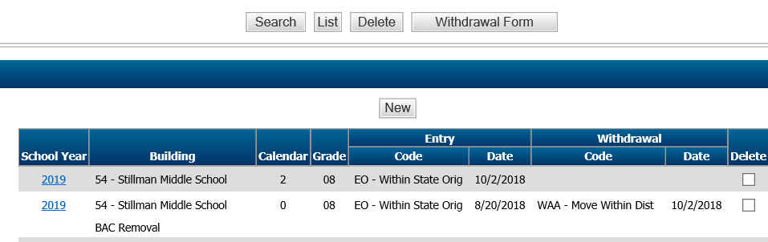

STEP 3 THROUGH STEP 4 – STUDENT RETURNING FROM BAC

- BAC Return (Withdrawal)
Must not be started until Transition Form is received from BAC.

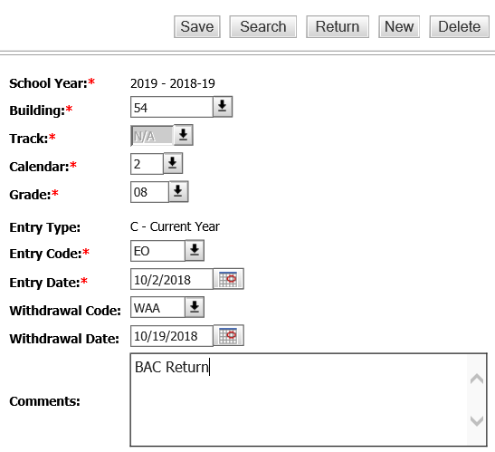

Use “Date to begin at Home Campus” noted on the BAC Transition Form.

Insert “Return” comment

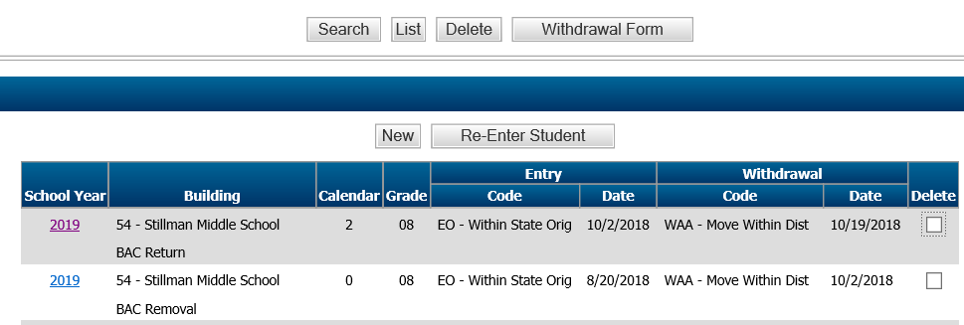

4. Open a NEW vector to re-enter to sending campus. Use same day student is withdrawn from BAC. Change the Calendar back to “0”.
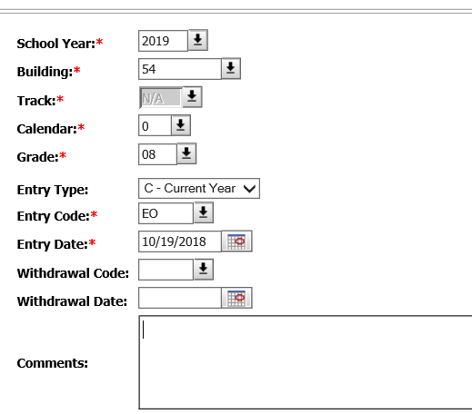
Calendar 0

Use “Date to begin at Home Campus” noted on the BAC Transition Form.

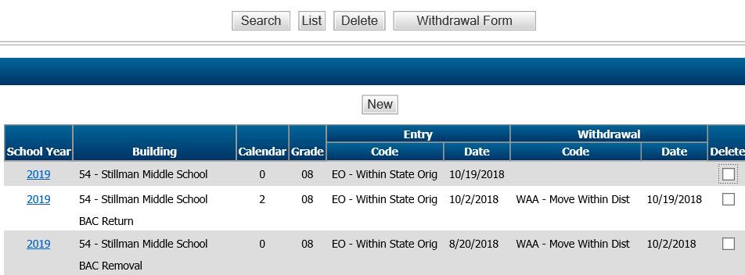

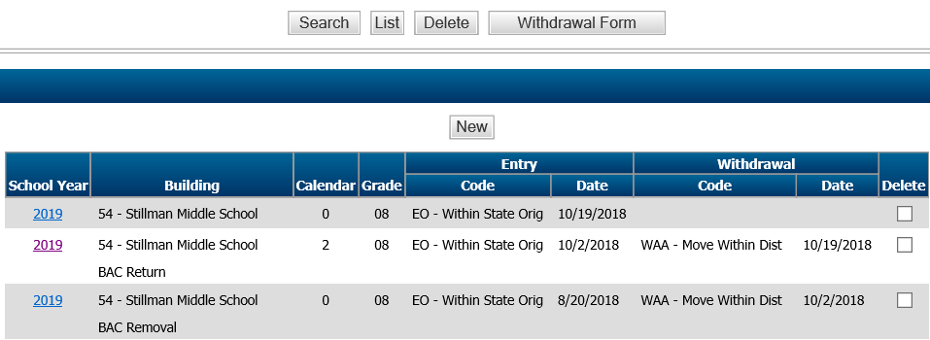
5. Complete withdrawal and entry screen for BAC Removal and Re-entry to sending campus

SAMPLE SCENARIOS

SAMPLE I. Student with pending days at BAC from prior school year
Comment notation
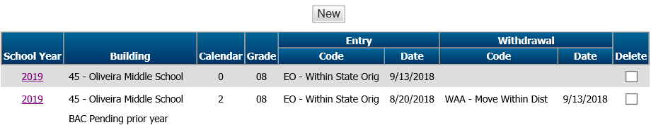

SAMPLE II. Student completes days at BAC and enrolls at another campus that is not sending campus.
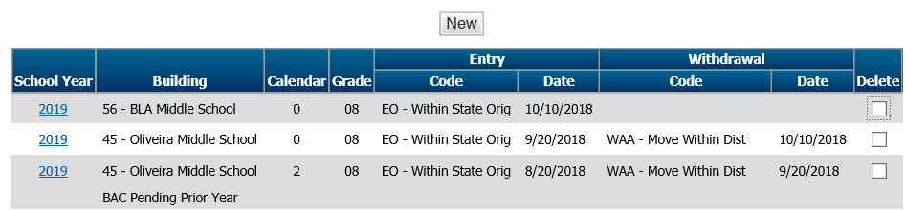

Comment notation
Withdrawal documents needed to report to other district campus.

