Intensive Program of Instruction (IPI) (revised 08/27/2013)
- Review all your student’s scores on the Eduphoria Aware program. Determine which students scored satisfactory and unsatisfactory on each STAAR test taken. An IPI must be documented for each STAAR subject the student scored unsatisfactory.
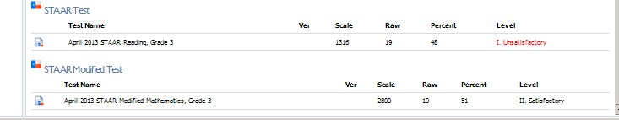

In this example, the student scored satisfactory in Math, but unsatisfactory in Reading. We must provide this student with an Intensive Program of Instruction in Reading.

- Call the parents and ask for consent to complete and ARD Amendment for this student. The ARD Amendment will: a.) revise the PLAAFP to include the weakness in the STAAR Testing Objectives, b.) add a goal and objective/s for each subject area in which the student scored unsatisfactory, and c.) document the IPI in the ARD document.

- Review the STAAR student Report for each STAAR subject the student scored unsatisfactory. Determine the Testing Objectives and Student expectations the student scored the lowest.
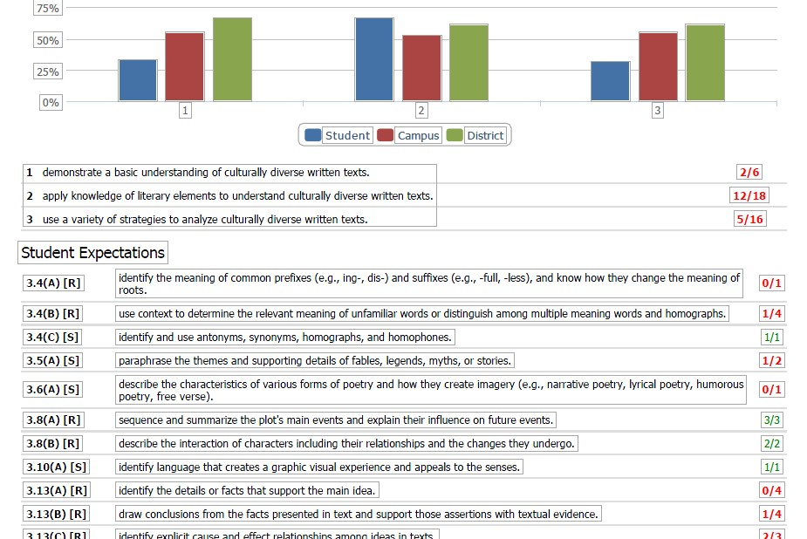

- Revise the PLAAFP to include the weakness noted on the Testing Objectives.

- Add a goal or goal and objective/s or add an objective to an existing goal, directly related to the testing objective that was found to be a weakness.
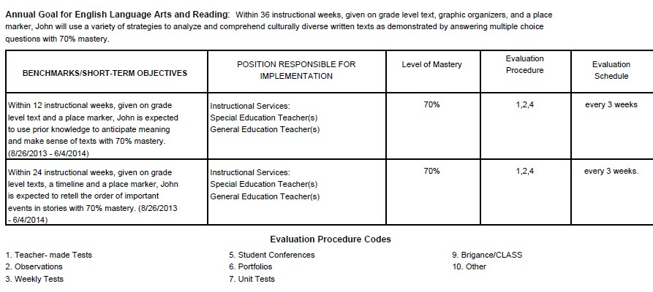

- Document the Intensive Program of Instruction (IPI) in the ARD.

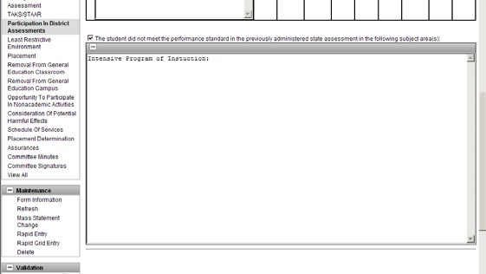

Go to the: PARTICIPATION IN DISTRICT
ASSESSMENTS, section of the ARD.
You will document the IPI in this box.
Example:

John did not meet performance standard in the April 2013 Administration of the STAAR Reading Test.
His Intensive Program of Instruction includes:
Review and revised PLAAFP to include weakness in Testing Objectives.
Review and revised Goals and Objectives that target the weakness in the Testing Objectives.
John will participate in tutorials as scheduled by the campus principal 45 minutes 3 times per week.

